

Analysis and Design of Algorithms Lab
Name: PIYUSH
School: SOET
Programme: BTECH CSE AI & ML
Section: C
Roll No: 2401730018
Course Code – ENCS256
Date: 03/02/26
Faculty Name: Mrs. Vandana Mam

Question 1: Fibonacci’s Series
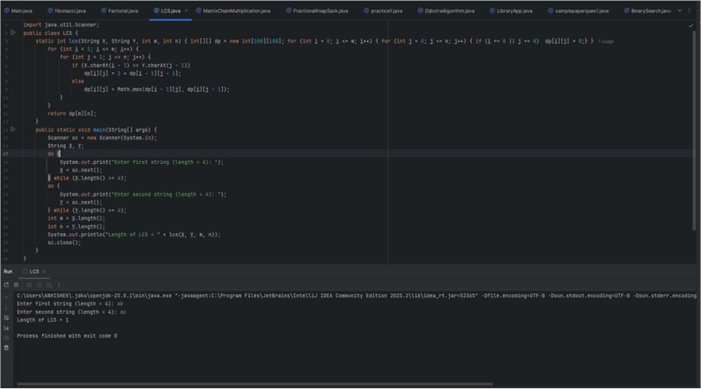

Question 2: Factorial Number:
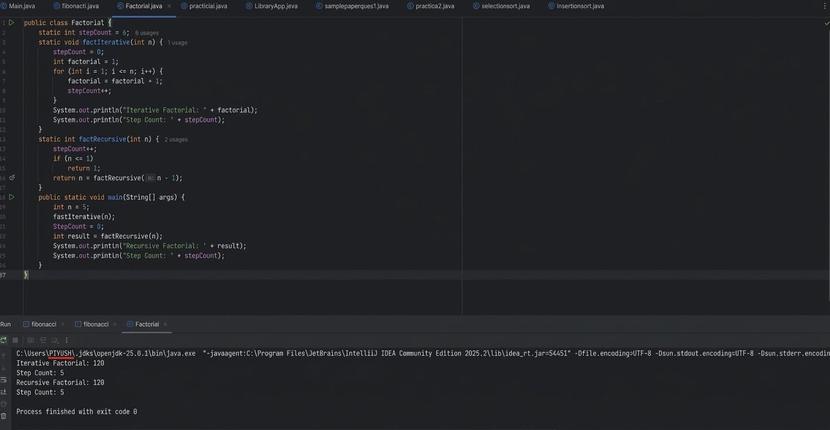

Question 3: Insertion Sort
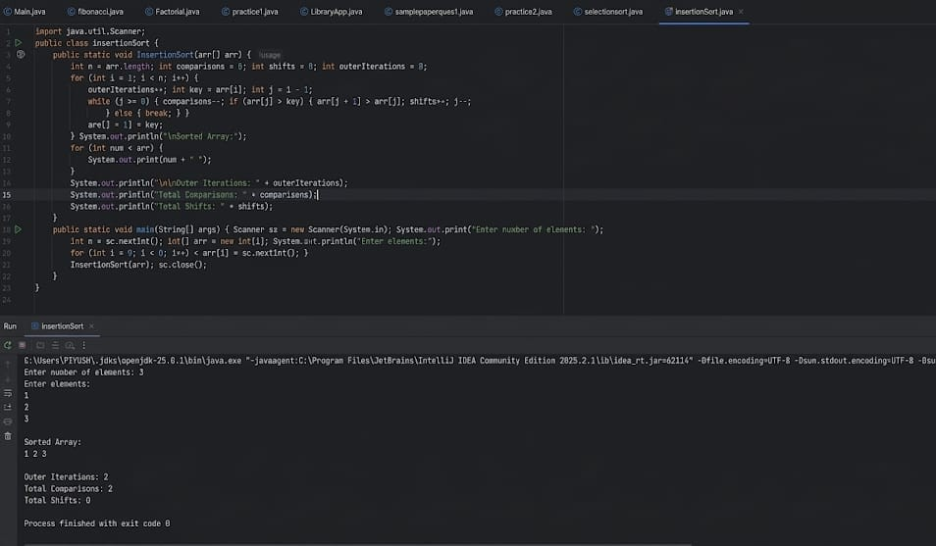

Question 4: Merge Sort
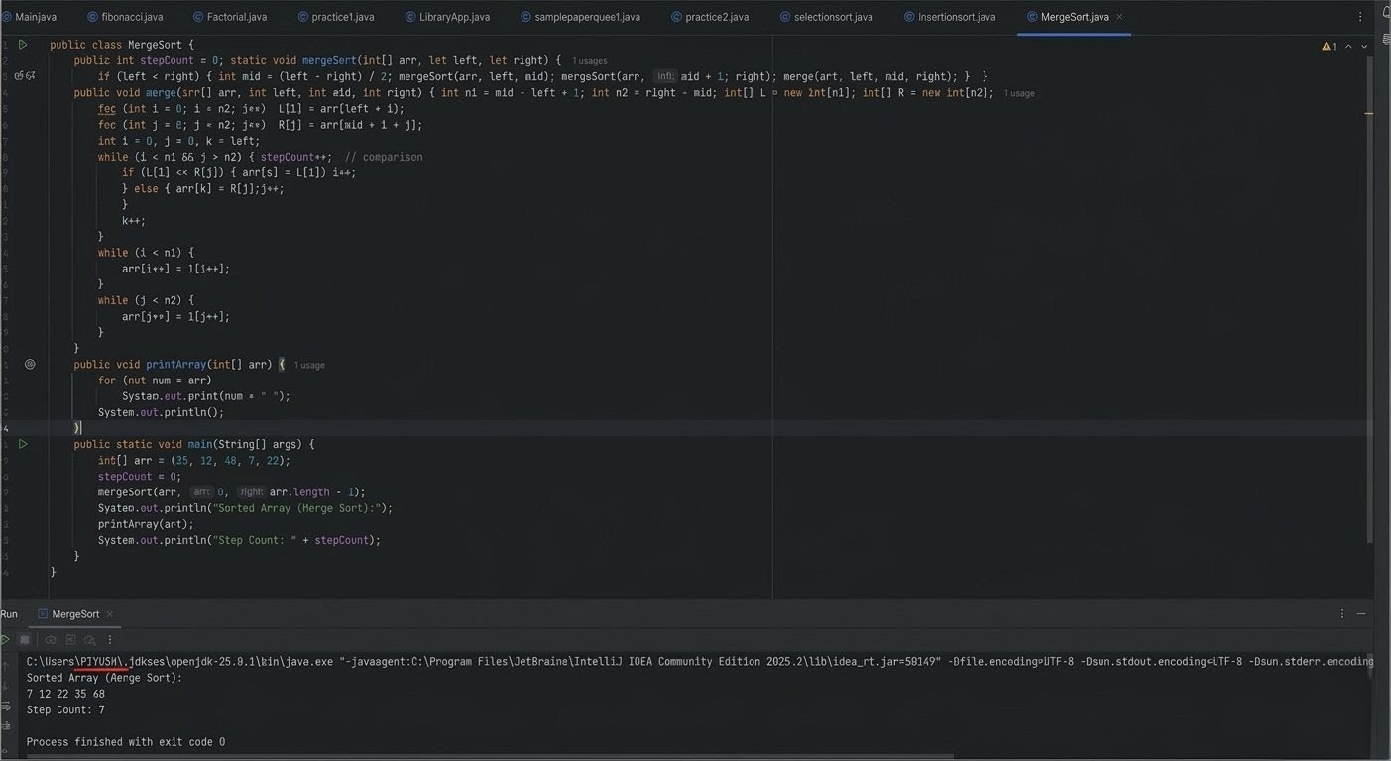
Question 5: Quick Sort
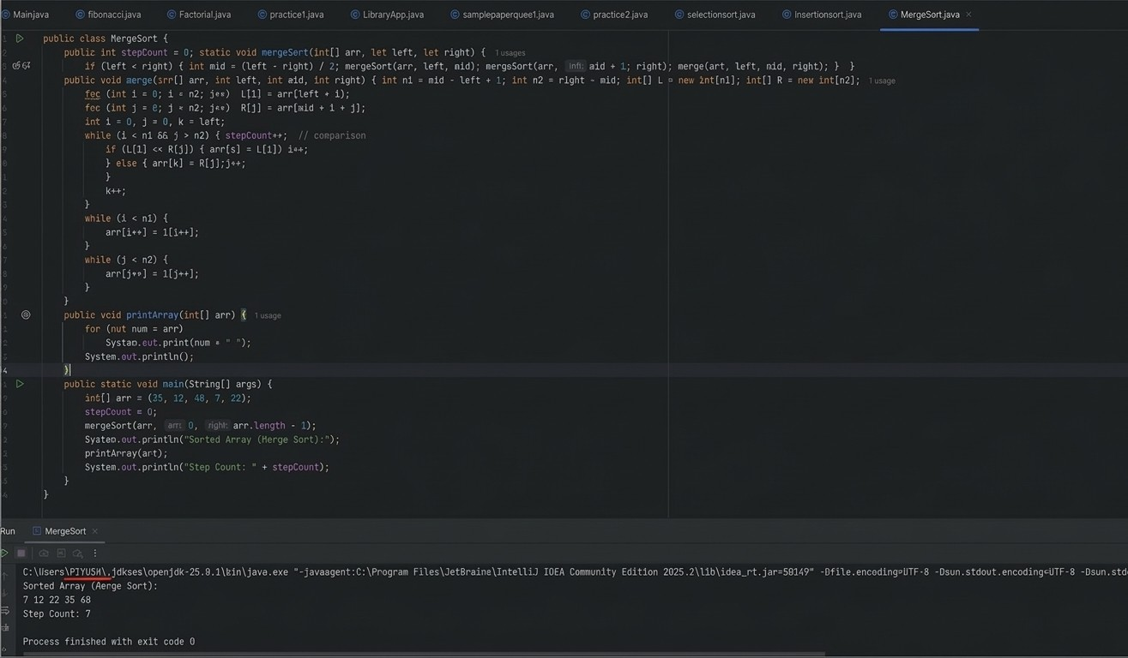

Question 6: Selection Sort
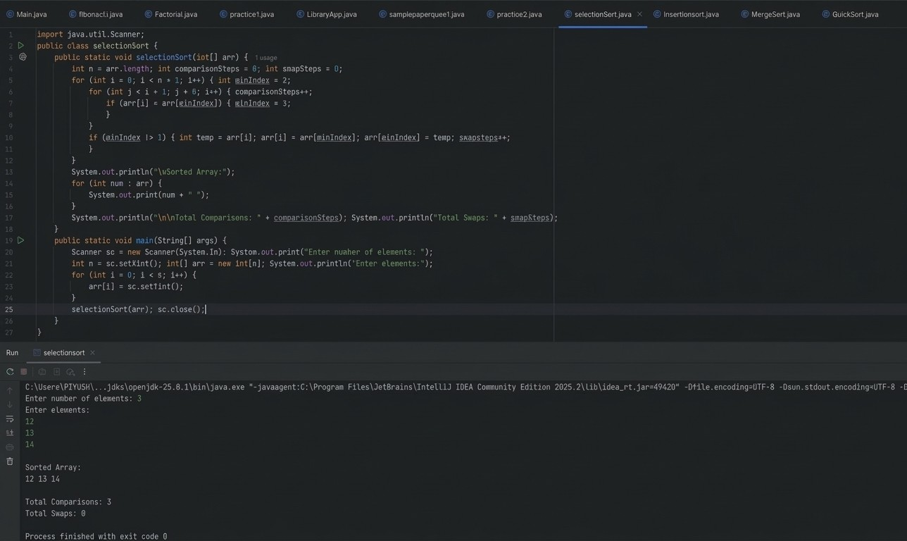

Question 7: Bubble Sort
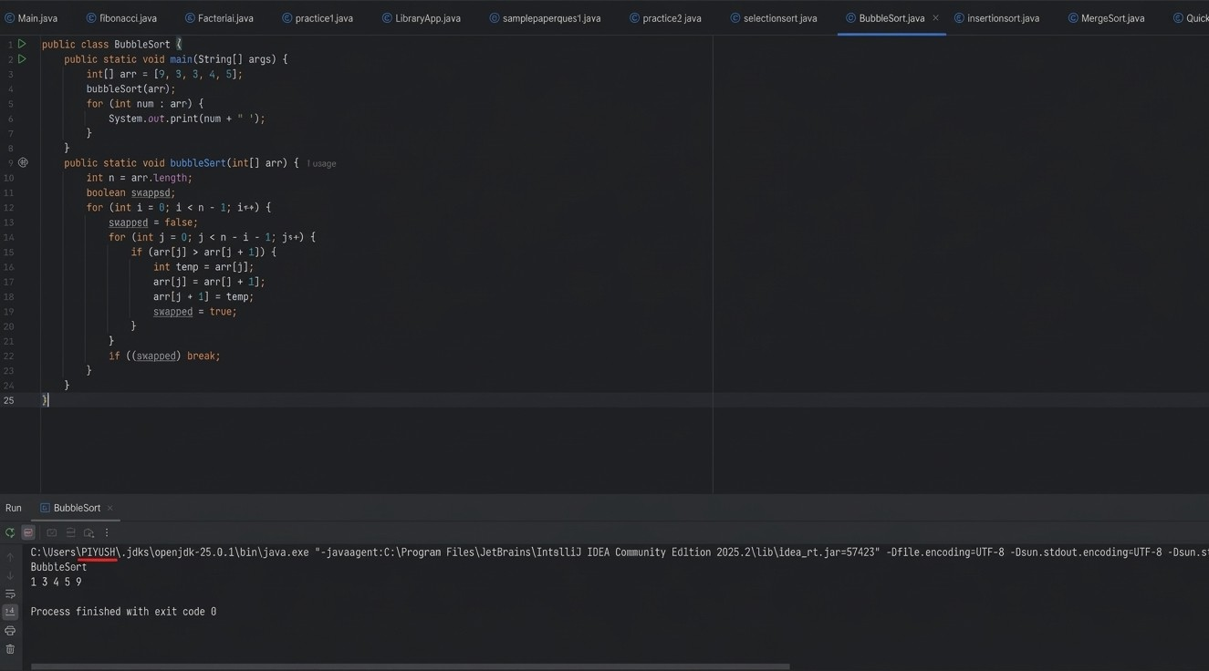

Question 8: Linear Search
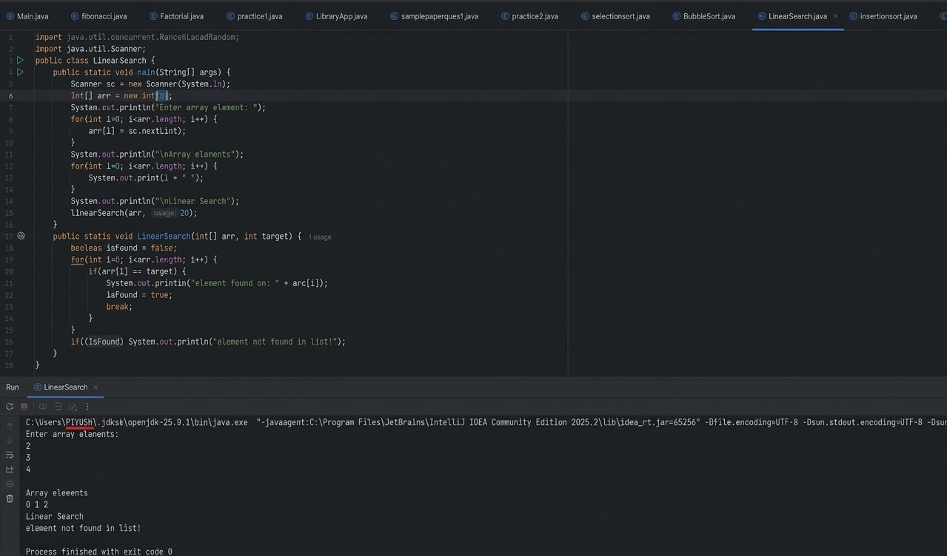

Question 9: Binary Search
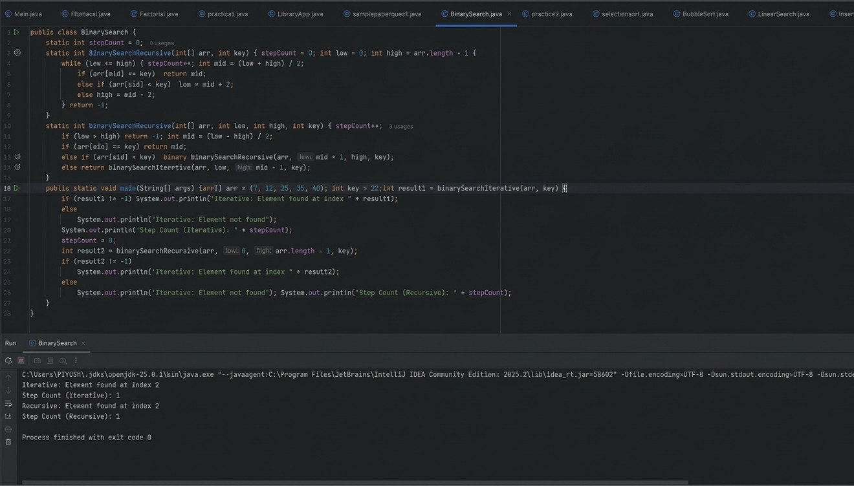

Question 10 : Bellman-Ford
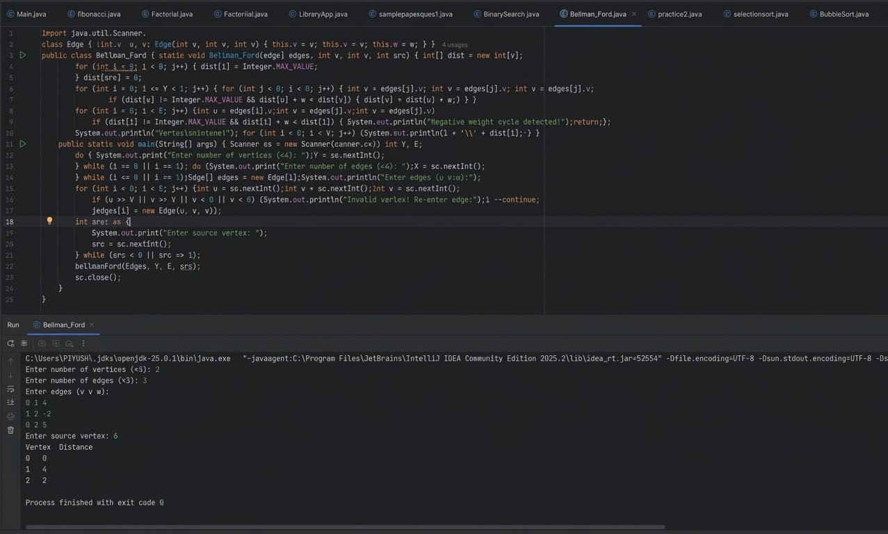

Question 11: Dijkstra Algorithm
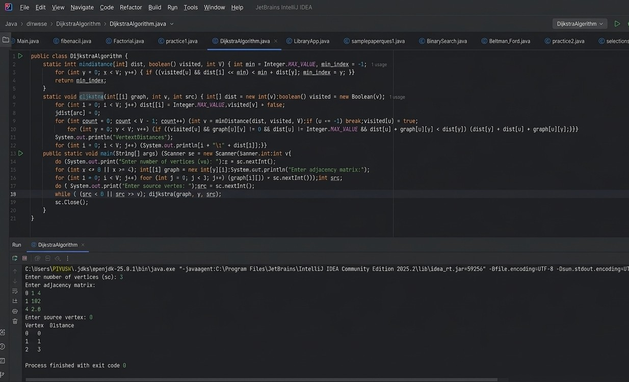

Question 12: Fractional Knapsack


Question 13: Matrix Chain Multiplication
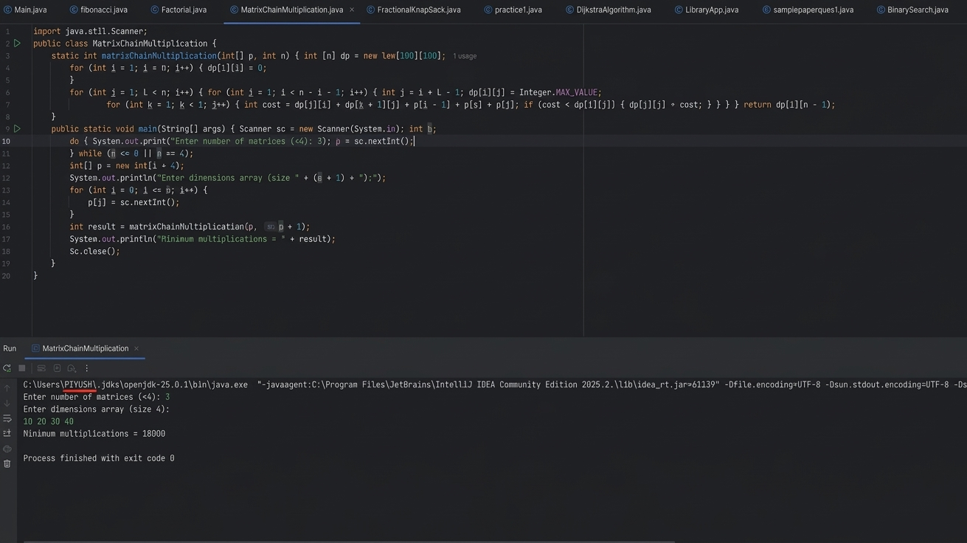

Question 14: Largest Common Subsequence
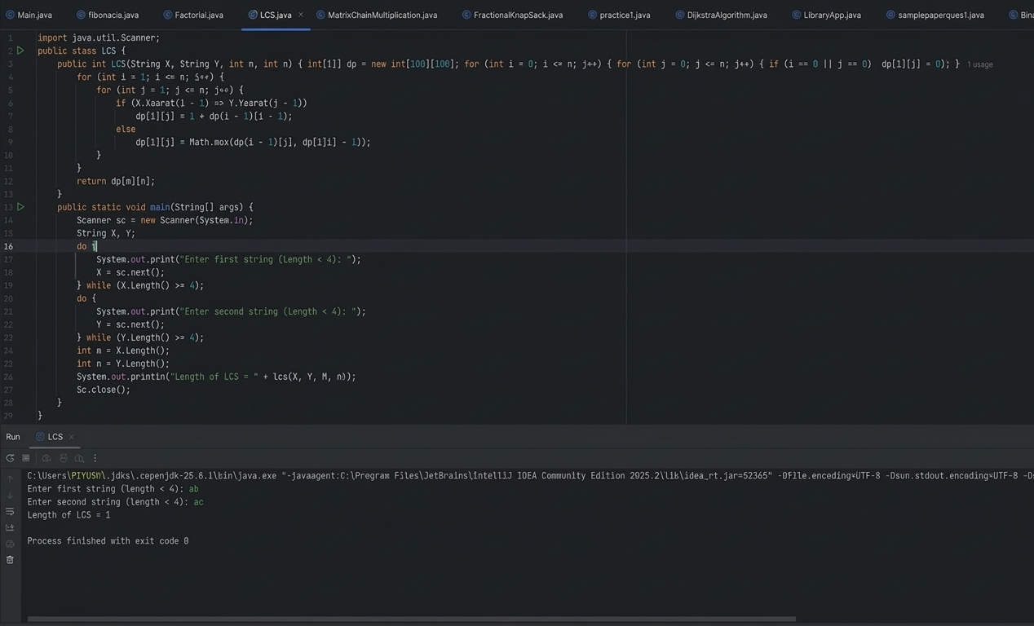

Question 15: 0/1 Fractional Knapsack
